

**Lab no.: 3 Date: February 11, 2023**

**Write a recursive program to find the GCD of given inputs.**

The greatest common divisor (GCD) of two or more numbers is the greatest common factor number that divides them, exactly. It is also called the [highest common factor (HCF)](https://byjus.com/maths/hcf/). For example, the greatest common factor of 15 and 10 is 5, since both the numbers can be divided by 5.

15/5 = 3

10/5 = 2

If a and b are two numbers then the greatest common divisor of both the numbers is denoted by gcd(a, b). To find the gcd of numbers, we need to list all the factors of the numbers and find the largest common factor.

**Methods to Find GCD**

There are several methods to find the greatest common divisor of given two numbers.

1. Prime factorization method
2. Long division method
3. 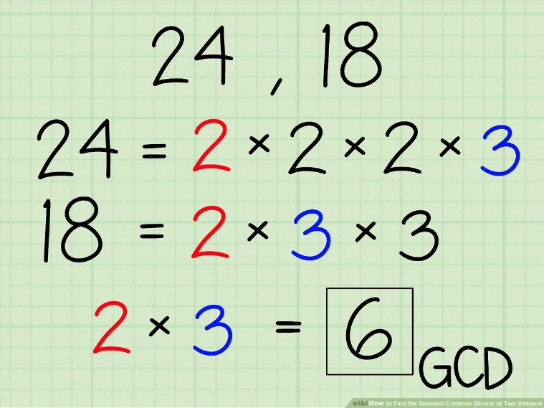Euclid’s division algorithm

**Programming Language: C**

**IDE: Microsoft Visual Code**

**Source code:**

#include <stdio.h>

int gcd(int a, int b)

{

if (b == 0)

return a;

else

return gcd(b, a % b);

}

int main()

{

printf("....GCD CALCULATOR....\n");

printf("\nEnter two numbers: ");

int n1, n2;

scanf("%d %d", &n1, &n2);

if (n1 < n2)

{

int temp = n1;

n1 = n2;

n2 = temp;

}

int res = gcd(n1, n2);

printf("The GCD of %d and %d is: %d", n1, n2, res);

}

**Outputs:**

